BPU British Bench Press Championships
Flight A
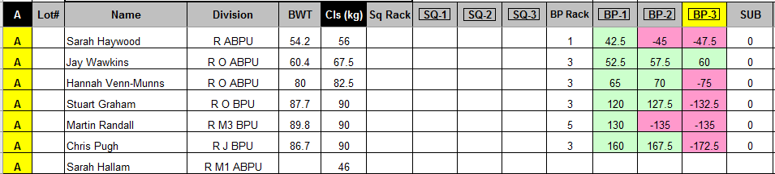
Flight B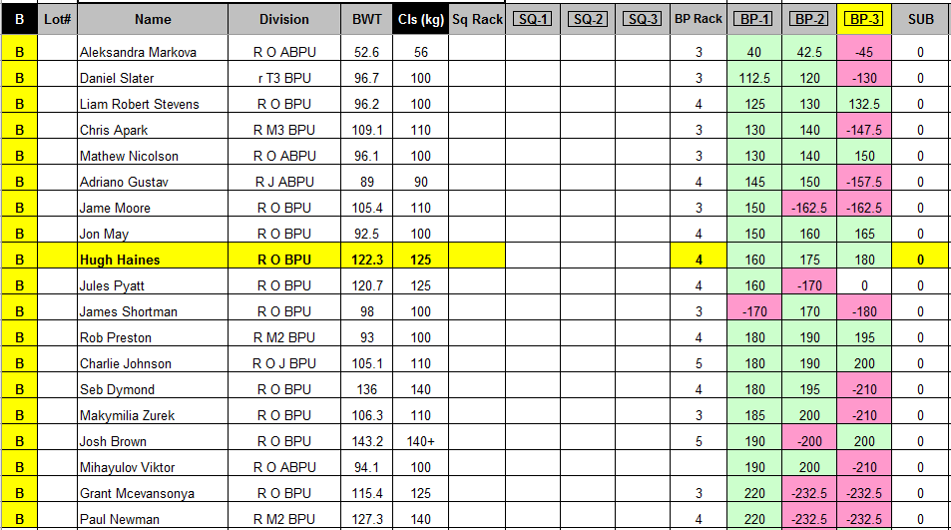
Flight C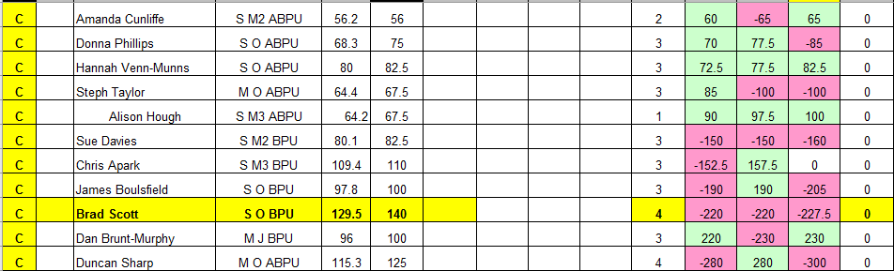

Flight D – Team Comp
